**Analysis of Airport Data using Hadoop-Hive**

1. **creating table airport for airports_mod.dat**:

**Command:** create table airport (Airport_ID string, Name string, City string, Country string, IATA_FAA string, ICAO string, Latitude string, Longitude string, Altitude string, Timezone string, DST string, TZ string) row format delimited fields terminated by ',';



2.**creating table finalairlines for Final_airlines** :

**Command:** create table finalairlines (Airline string, Name string, Alias string, IATA string, ICAO string, Callsign string, Country string, Active string) row format delimited fields terminated by ',';

3. **Creating table route for routes.dat**:

**Command:** create table route(Airline string, Airline_ID string, Source_airport string, Source_airport_ID string, Destination_airport string, Destination_airport_ID string, Codeshare string, Stops string, Equipment string) row format delimited fields terminated by ',';



4. **loading data into airport table**

**Command:** load data local inpath '/home/edureka/bhargav/Air-datasets/airport' into table airport;

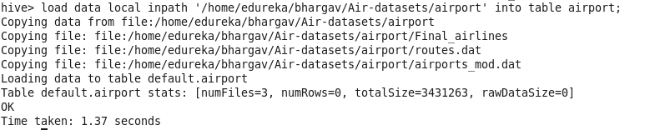

5. **loading data into finalairlines table**

**Command:** load data local inpath '/home/edureka/bhargav/Air-datasets/finalairlines' into table finalairlines;

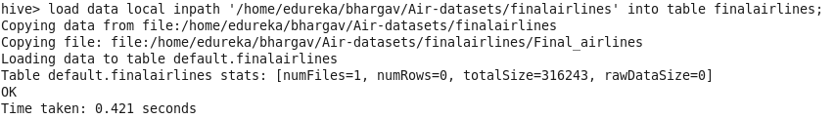

6**.loading data into route table**

**Command:** load data local inpath '/home/edureka/ bhargav/Air-datasets/route' into table route;

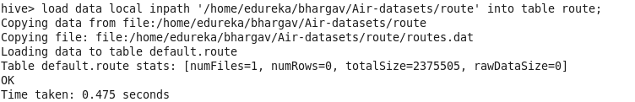

**Problem solution**:

a) **Find list of Airports operating in the Country India**;

**Command:** create table india_opert_airport as select * from airport where Country LIKE '%India%';

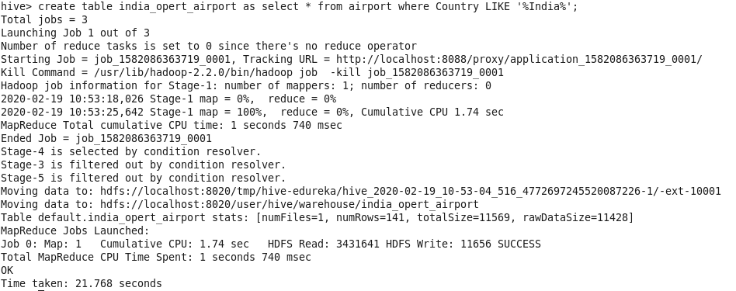

**Command:** select * from india_opert_airport limit 10; (to show only first 10 values due to large nos of data)

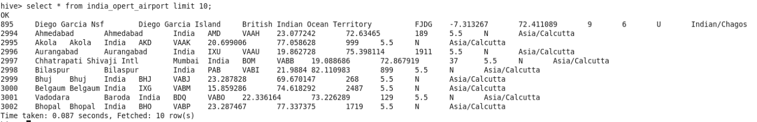

b.**Find the list of Airlines having zero stops**

**Command:** create table stop as select * from route where Stops LIKE '%0';

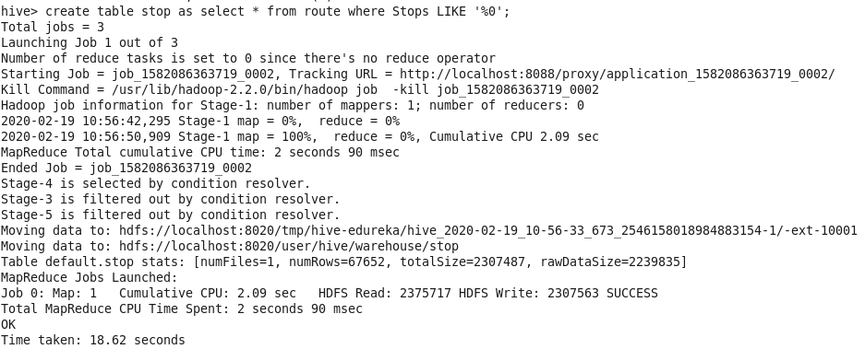

**Command:** select * from stop limit 10;

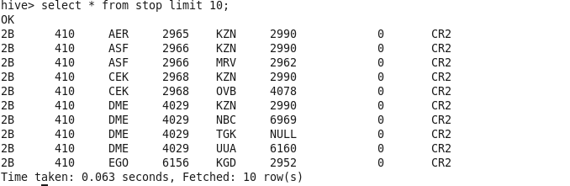

**c.List of Airlines operating with code share**

**Command:** create table codeshare_1 as select * from route where Codeshare LIKE '%Y%';

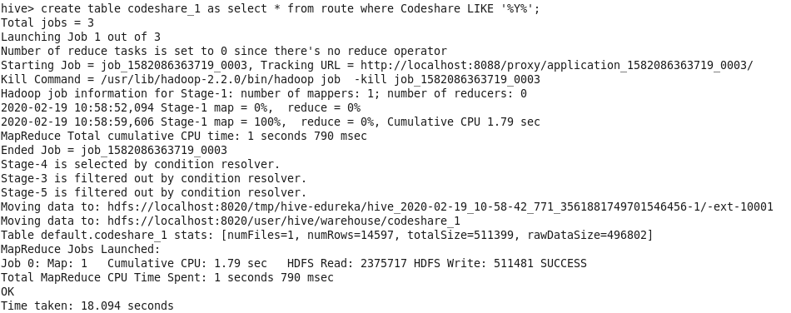

**Command:** select * from codeshare_1 limit 10;

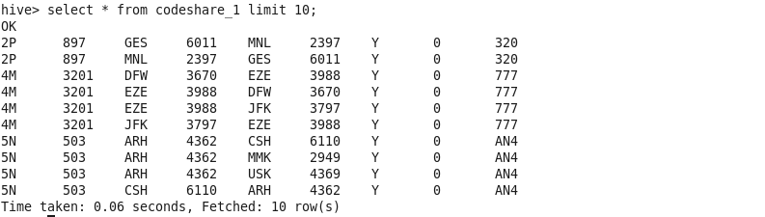

**d.Which country (or) territory having highest Airports**

**Command:** select Country,count(*) as cnt from airport group by Country SORT BY cnt DESC;

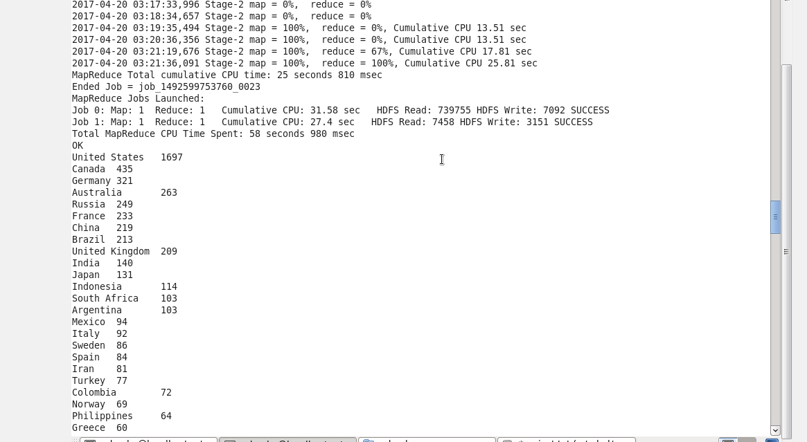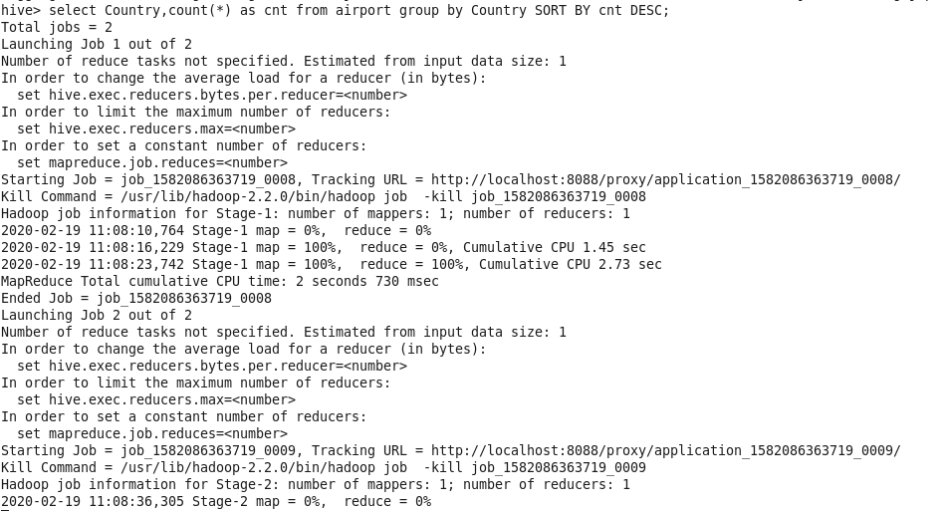

**E. Find the list of Active Airlines in United state**

**Command:** select * from finalairlines where Country like '%United States%' AND Active like '%Y%';

